J1699 V13.00.0X
Compliance Testing

The J1699 test is an Industry wide compliance test tool. All manufacturers that sell vehicles in North America use this tool to demonstrate compliance with the Generic Scan Tool, Modes 1-9. These Modes were legislated so that aftermarket repair facilities could access OBD controller information with one common or Generic Scan Tool.

- When testing a vehicle make sure that ALL OBD controllers have been up-dated. All too often, a calibrator will ask you to test a new ECM software release and not up-date the TCM, leading to a failure of the J1699 test.

- Contact your J2534 device supplier for their latest firmware release.

- Use the Ethernet or USB port for data collection. Do not use the serial port.

- When asked if you want to run the Static or Dynamic test, start with Static. The Static test can be run without moving the vehicle. Dynamic Test requires that the vehicle be driven until ALL I/M Readiness Flags are set to yes and ALL Numerators and Denominators have incremented by one. This could take multiple trips to complete.

- The Year, Make & Model you enter at the beginning of the J1699 test will be the Log File name for the Static Test. You must enter the correct Model Year (e.g., 2007), no other text as this value is used for some J1699-3 evaluation criteria.

- The VIN will be the file name for the Dynamic Test. This file name will be automatically generated by what is stored in Mode 9 VID 02. The J1699 tool will append to this file as you enter and exit from the J1699 application during the testing.

- When setting a ‘Type B’ DTC make sure you know the FAIL and PASS criteria for
that DTC. I typically will disconnect a MAP or MAF sensor because it runs extremely fast; it runs at idle and does not require a vehicle speed input. This is not true for all applications! Know your vehicle!

- J1699 may not work correctly if you set multiple DTC’s.

- Review the Log File in a Word format. This allows you to enter comments in the log describing the anomalies detected by J1699. E-Mail the .log file to: Kevin Stofflet at mailto:kstofflet@engenius.com if you have a question or comment on J1699 performance.

- J1699 software can be found at http://sourceforge.net/projects/j1699-3.
Dynamic Test Overview

The Dynamic test consists of 2 main parts, Test 10 and Test 11. You will complete Test 10 during one session and complete Test 11 in a separate session. Since multiple cold starts are required to complete Test 11, multiple sessions are required.

The J1699 program generates a log file. This log file contains information that will allow you to bypass Test 10 once you have successfully completed it. If you are resuming Test 11, make sure you use the same log file. If you type in a different log file name, the IM Ready flags that were completed in Test 10 will be cleared and you will have to repeat Test 10.

Specific conditions are needed to meet the OBD and EVAP conditions. The J1699 program checks whether you have incremented the OBD and EVAP condition counters (if supported) before you can successfully complete this testing. (The CARB definitions are included at the end of this document). Make sure you meet these conditions before starting:
Ambient temperature > 20F for OBD; Ambient > 40F and < 95F for EVAP
Altitude < 8000 feet (Any road east of the Mississippi) for both OBD and EVAP
Startup Coolant > 40F and < 95F for EVAP
Startup Coolant </= IAT + 12F for EVAP
Then you must make sure you complete the drive cycle at least once (30 sec idle followed by 300 sec drive > 25 mph and total 600 sec engine run). You will be prompted to complete the first OBD drive cycle (Test 10). You must perform your own ‘manufacturer specific’ drive cycle for Test 11.

The remainder of this section will guide you through the actual use of the J1699 program for Tests 10 and 11.
Dynamic Test Sample

Launch J1699.exe
Select “2” for Dynamic test.
Enter the appropriate responses for the your specific vehicle configuration.

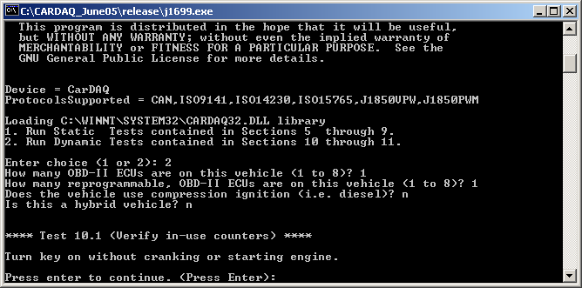

Turn the key on and press enter as instructed.

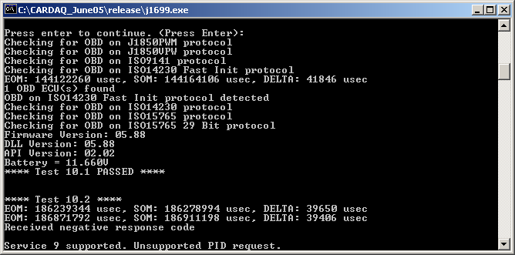

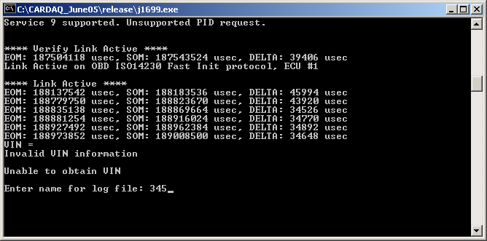
If the ECU has a VIN flashed in, the program will automatically find the VIN and create a log file using the VIN.

If the ECU does not have a VIN, you will be prompted to select a log file name.

The log file contains information that will allow you to bypass Test 10 once you have successfully completed it. If you are starting Test 11, make sure you use the same log.

At this point, Test 10 will begin. If the vehicle has already completed Test 10, the J1699 program will automatically move on to Test 11.
When running Test 10, the screen below will be displayed and you must now go through the OBD drive cycle.

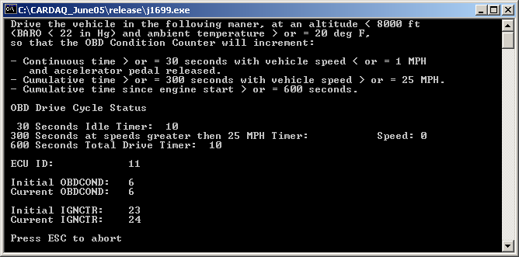

BE SURE TO COMPLETE A 30 SECOND CONTINUOUS IDLE FIRST!!!

Once the idle timer has reached 30 seconds, you must drive > 25 mph for 300 seconds and keep the engine running at least 600 seconds.

Once this OBD drive cycle is successfully completed, you will be prompted to pull over and idle BUT DON’T TURN THE KEY OFF.

The J1699 program will evaluate several engine conditions that require an engine run condition and will then move on to Test 11.

When Test 11 starts, the screen below will be displayed and you will be prompted to drive the vehicle to complete all OBD monitors and set all the supported I/M Readiness bits to a ‘Ready’ condition (this is a manufacture specific drive cycle). You can choose to use the J1699 program to monitor the status of the of the vehicle, but this is not required. If you select “n”, then the J1699 program will terminate and you should perform the drive cycle. After completing the drive cycle, you can restart the J1699 software will automatically proceed from this point.

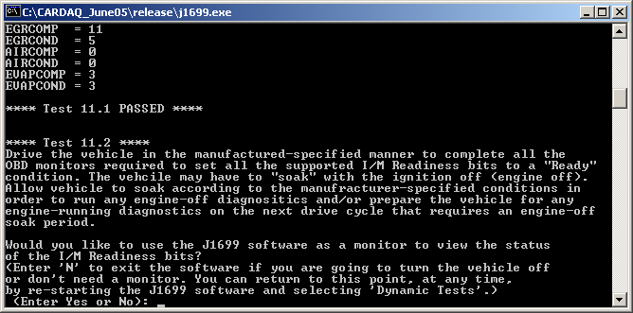

If you select “y” to monitor using the J1699 program, you will see the vehicle status. Here is an example of the screen.

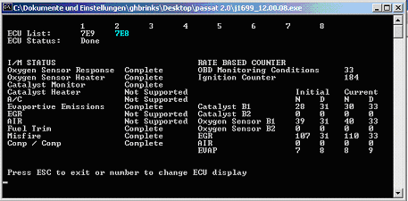
From this screen, you can select “ESC” or continue to monitor the status while you drive the necessary conditions to run the monitors. Remember to use the same log file name when reinitializing the test OTHERWISE, THE IM READY INFORMATION WILL BE CLEARED AND YOU WILL BE REQUIRED TO START OVER. The J1699 program will automatically leave the monitor screen when it has detected that the vehicle has successfully completed all OBD monitors and set all the supported I/M Readiness bits to a ‘Ready’ condition.

Follow the instructions on screen to complete the remainder of Test 11.

Be aware that the J1699 program will create two log files: one for the Static Test (Test 5-9), and one for the Dynamic Tests (Tests 10-11). Each log file will have a different name. The Static Test log file will be named based on the Model Year, Make, and Model entered at the start of the J1699 program. The Dynamic Test log file will be name will be based on the VIN (or user file name if a valid VIN is not present on the vehicle). In either case, the J1699 program will not over-write an existing file – it will append a “-xx”; where the xx will start a 1 and continue to increment each time an existing file name is re-used.

Appendix A: OBD and EVAP Drive Condition Definitions

As a guide, the OBD and EVAP drive condition definitions are as follows (please consult the official regulation for the current requirements):

From CARB Specifications:
(4.3) Denominator Specifications
(4.3.1) Definition: The denominator is defined as a measure of the number of times a vehicle has been operated as defined in (d)(4.3.2).
(4.3.2) Specifications for incrementing:
(A) The denominator, when incremented, shall be incremented by an integer of
one. The denominator may not be incremented more than once per driving cycle.
(B) The denominator for each monitor shall be incremented within ten seconds if
and only if the following criteria are satisfied on a single driving cycle:
(i) Cumulative time since engine start is greater than or equal to 600
seconds while at an elevation of less than 8,000 feet above sea level and
at an ambient temperature of greater than or equal to 20 degrees Fahrenheit;
(ii) Cumulative vehicle operation at or above 25 miles per hour occurs for
greater than or equal to 300 seconds while at an elevation of less than
8,000 feet above sea level and at an ambient temperature of greater than
or equal to 20 degrees Fahrenheit;
(iii) Continuous vehicle operation at idle (i.e., accelerator pedal released by
driver and vehicle speed less than or equal to one mile per hour) for
greater than or equal to 30 seconds while at an elevation of less than
8,000 feet above sea level and at an ambient temperature of greater than
or equal to 20 degrees Fahrenheit;
(C) In addition to the requirements of section (d)(4.3.2)(B) above, the secondary
air system monitor denominator(s) shall be incremented if and only if
commanded “on” operation of the secondary air system occurs for a time
greater than or equal to ten seconds. For purposes of determining this
commanded “on” time, the OBD II system may not include time during
intrusive operation of the secondary air system solely for the purposes of
monitoring;
(D) In addition to the requirements of section (d)(4.3.2)(B) above, the
evaporative system monitor denominator(s) shall be incremented if and only
if:
(i) Cumulative time since engine start is greater than or equal to 600
seconds while at an ambient temperature of greater than or equal to 40
degrees Fahrenheit but less than or equal to 95 degrees Fahrenheit;
(ii) Engine cold start occurs with engine coolant temperature at engine start
greater than or equal to 40 degrees Fahrenheit but less than or equal to
95 degrees Fahrenheit and less than or equal to 12 degrees Fahrenheit
higher than ambient temperature at engine start.

